Hi Carey,

Please find below a COE/refund recommendation for approval:
473835552 Eva Fox-Venz

1. Course Code and Name: CHC33021-DISABI - Certificate III in Individual Support (Disability)
2. Liability Category: ENT
3. Citizenship: Australian
4. Application date: 06/11/2025
5. CESD: 14/07/2025
6. Census Date: NA
7. Reason for COE:
Medical reasons
The student’s request is supported by a medical certificate indicating multiple medical conditions that affect her ability to cope with studying and placement, making medical reasons the most appropriate category.
Special Circumstances eligibility:
Beyond control: MET – The medical conditions cited (ASD, ADHD, anxiety, etc.) are inherent health issues beyond the student’s control.
After start of study/census: NOT CLEAR – The certificate is dated 12/11/2025, which is after the course commencement (14/07/2025), but it is unclear when the conditions began to impact the student’s ability to study or if the full impact was only realized after the start date.
Unreasonable to complete: MET – The medical certificate explicitly states the student is unfit to complete the TAFE course, indicating it is unreasonable for her to continue within the current timeframe.
Documentation assessment:
Independence of documentation: The medical certificate is from a registered medical practitioner, independent and appropriate.
Noted gaps/limitations: The certificate does not specify when the conditions began to affect study or when it became apparent the student could not continue; no detailed explanation of impact on assessments or attendance.
Further documentation was requested on 24/11/2025. However, we received no response from student.
Timeline of events:
14/07/2025 – Course (CHC33021 - Certificate III in Individual Support Disability) commences (EASD).
12/11/2025 – Medical certificate issued by Dr. Sune Kilian confirming medical conditions and unfitness to complete course.
05/12/2025 – Student lodges withdrawal and refund application with TAFE Queensland.
Impact on study (summary):
• The student’s medical conditions have impaired her ability to cope with both studying and placement requirements.
• She is currently unable to attend or fully engage with classes and placement activities.
• The conditions have likely affected her capacity to submit assessments or meet course timelines.
• The medical certificate indicates she is unfit to complete the course, suggesting significant impact on study continuation.
8. Has evidence been supplied: Yes
9. AHPRA Verified?: Yes
10. Account Balance: $0.00
11. Financial Impact:
CHCCCS033 [ENG: 41.25] Fee Waiver $5.00
CHCLEG001 [ENG: 32.42] Fee Waiver $5.00
CHCCOM005 [ENG: 10.60] Fee Waiver $5.00
CHCCCS031 [ENG: 73.58] Fee Waiver $5.00
CHCCCS040 [ENG: 50.87] Fee Waiver $5.00
CHCDIV001 [ENG: 13.25] Fee Waiver $5.00
HLTINF006 [ENG: 9.27] Fee Waiver $5.00
HLTWHS002 [ENG: 6.62] Fee Waiver $5.00
Total Fee Waiver: $40.00 (8 units)
12. Recommendation:
Please choose an option.
1. Post EASD WID FREF 8 units and apply fee waiver of $40.00 (8 @ $5.00) = $40.00 refund to student account and waive administration fee.
2. Post EASD WID FREF 8 units and apply fee waiver of $40.00 (8 @ $5.00) = $40.00 credited to student account. Administration fee applicable. $40.00 - $100.00 Administration fee = no refund to student.
3. Post EASD WID NREF 8 units. No refund to student. The medical certificate lacks detailed information on when symptoms worsened or how the conditions specifically impacted study timelines. Further documentation was requested and no statement was given by the student.


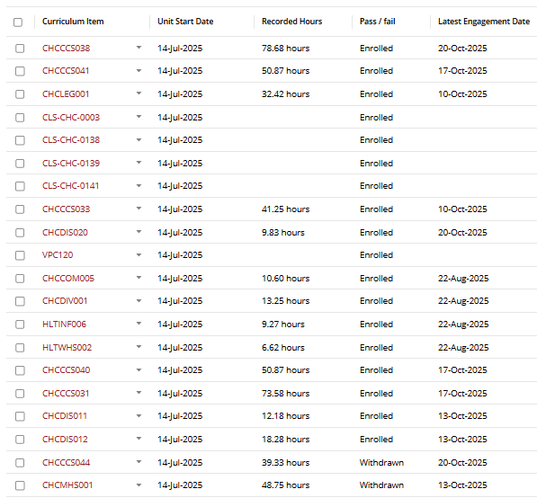
By sending through this request, I acknowledge that I am aware of TAFE Queensland Procedure 650 Student Fees, the TAFE Queensland Financial Management Delegations and will be processing the above transaction in SMS as per the FACT SHEET - Fee Waivers, Reversals and Overrides

Kind regards,
Sien

